

**St Therese of Lisieux P.S**

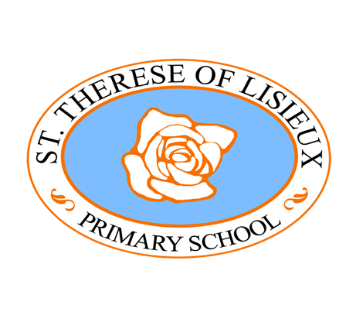

**DRAFT Period Dignity Policy**

**Mission Statement**

As a thriving Catholic school, rooted in Christ’s ministry and message, we offer a child-centred, ambitious, inclusive and holistic education; we work in partnership, in a nurturing and supportive atmosphere, building a flourishing and diverse community of care, love and aspiration.

**Nurture Support Grow**

**Aims**

**We aim to promote high achievement and learning for life by:**

Providing a holistic education within a happy, nurturing, inclusive, and stimulating learning environment.

Supporting and encouraging each child to flourish by delivering a broad and balanced curriculum, which is appropriate to their individual needs.

Fostering positive, caring relationships within the whole school community based on respect and empathy.

Setting high expectations and promoting the well being and resilience of pupils and staff.

Promoting, developing and celebrating our children’s individual talents, skills, abilities and successes.

Supporting our pupils to develop the appropriate social, emotional and behavioural skills needed to thrive at school and beyond.

**Period Dignity Policy**

**Definition**

Period dignity refers to the right to manage menstrual cycles in a way that is healthy, affordable, and free from stigma and discrimination. This concept encompasses:

* **Affordable Access:** Ensuring menstrual products are affordable and accessible to everyone.
* **Shameless Access:** Removing the stigma and taboo associated with menstruation.
* **Broad Access:** Providing access to necessary facilities, such as washing facilities and disposal options.

In essence, period dignity is about achieving period equity and addressing period poverty.

**Aim/Purpose**

The NI Executive agreed in December 2020 that free period products should be made available to all schools from September 2021.

The Period Dignity scheme aims to promote period dignity and tackle period poverty. The free products are not aimed at providing a blanket provision, but the scheme aims to ensure products are available to those that need them, where and when they need them.

The purpose of this policy is to ensure that children, staff and visitors at St Therese of Lisieux Primary School have access to the necessary resources and support to manage their periods with dignity and without embarrassment or stigma.

**Scope**

This policy applies to children, staff, and visitors at St Therese of Lisieux Primary School.

**Policy Statement**

St Therese of Lisieux Primary School is committed to:

* Providing free access to menstrual products for children, staff and visitors who need them.
* Educating Key Stage 2 children about menstruation in a respectful and inclusive manner.
* Creating a supportive environment where children feel comfortable discussing menstruation and seeking help if needed.
* Ensuring that staff are trained to support children with their menstrual health needs.

**Access to Menstrual Products**

* Free menstrual products will be available in the Key Stage 2 girls' toilets and other designated areas to include Ladies Toilets and Accessible Toilets.
* Children will be informed about the availability and location of these products through an information session led by their class teachers at the beginning of each academic year and during the year as required. Staff will be informed at the beginning of the school year through the Staff Handbook.

**Education and Awareness**

* The school will incorporate age-appropriate education about menstruation into the PDMU/RSE curriculum in KS2.
* Workshops and information sessions will be held to educate P6 and P7 children about menstrual health and period dignity.

**Supportive Environment**

* The school will foster an environment where children feel safe and supported in discussing menstruation.
* Staff will handle menstruation-related issues with sensitivity and confidentiality.
* Children will be encouraged to speak to a trusted adult if they have any concerns or need assistance.

**Role of Parents/Guardians**

Parents & Guardians have a key role in explaining periods to their child and that this is a normal and natural part of growing up. It is important to acknowledge again, that children mature at different rates. The NHS recommends that parents should talk about periods as part of an ongoing process rather than a formal sit-down talk. Advertisements for sanitary products may be a place to start or simply ask the child what they know. Parents are encouraged to talk to their child about periods when they see early signs of puberty (see useful resource links at the end of the document).

According to NHS the early signs of puberty in girls are:

* Spots or acne;
* More hair on legs and arms; and
* Breasts begin to develop

**Policy formation and consultation process**

This policy has been drawn up after attendance at Period Dignity Training provided by CCEA and consideration of CCEA advice and guidance documents.

We have consulted with the following stakeholders;

• Governors

• Parents

• KS2 pupils

• Staff and visitors

**Links to other policies**

This policy should not be seen in isolation and should be cross referenced with other school policies, in particular the Personal Development and Mutual Understanding Policy, Relationships and Sexuality Policy, the Safeguarding and Child Protection Policy, Special Educational Needs Policy, Intimate Care Policy, First Aid Policy, Educational Visits Policy and the Equality & Inclusion Policy.

**Monitoring and Review**

The implementation of this policy will be monitored by KS2 staff and the PDMU Coordinator, as well as the Senior Leadership Team. Feedback from children, parents, and staff will be sought periodically to ensure the policy is effective. The policy will be reviewed and updated as necessary.

USEFUL RESOURCE LINKS

<https://www.nhs.uk/conditions/periods/starting-periods/>

<https://kidshealth.org/en/parents/talk-about-menstruation.html>

<https://ccea.org.uk/learning-resources/living-learning-together>